Combine Retrieval with Generation (RAG)
Retrieval-augmented generation (RAG) is an innovative approach in the field of natural language processing (NLP) that combines the strengths of retrieval-based and generation-based models to enhance the quality of generated text.
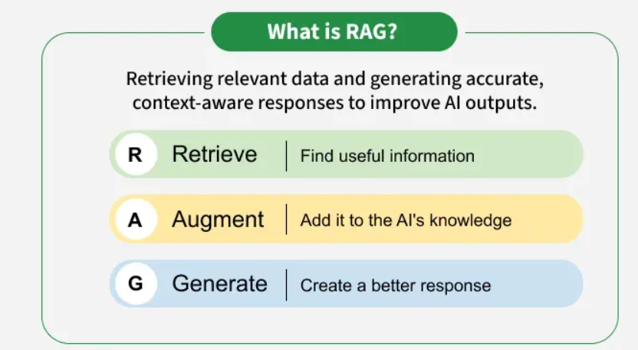

Why is Retrieval-Augmented Generation important?
In traditional LLMs, the model generates responses based solely on the data it was trained on, which may not include the most current information or specific details required for certain tasks. RAG addresses this limitation by incorporating a retrieval mechanism that allows the model to access external databases or documents in real-time.
This hybrid model aims to leverage the vast amounts of information available in large-scale databases or knowledge bases making it particularly effective for tasks that require accurate and contextually relevant information.

How does Retrieval-Augmented Generation work?
The system first searches external sources for relevant information based on the user’s query instead of relying only on existing training data.
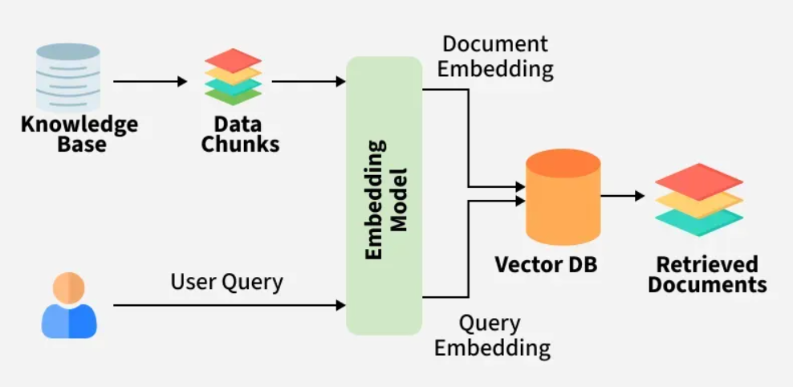
1. Creating External Data
External data refers to new information beyond the LLM’s original training dataset. It can come from various sources, such as APIs, databases, or document repositories, and may exist in different formats like text files or structured records. To make this data understandable to AI, it is first divided in chunks in case of massive datasets and converted into numerical representations (embeddings) using specialized models and then stored in a vector database. This creates a knowledge library that the AI system can reference during retrieval.
2. Retrieving Relevant Information
When a user submits a query, the system converts it into a vector representation and matches it against stored vectors in the database. This enables precise retrieval of the most relevant information. For example, if the Y.O.G.I Bot is asked, "What are the key topics in the DSA course?", it would retrieve both the course syllabus and relevant study materials. This ensures the response is highly relevant and tailored to the user's learning needs.
3. Augmenting the LLM Prompt
Once the relevant data is retrieved, it is incorporated into the user’s input (prompt) using prompt engineering techniques. This enhances the model’s contextual understanding, allowing it to generate more detailed, factually accurate, and insightful responses.
4. Keeping External Data Updated
To ensure the system continues to provide reliable and up-to-date responses, external data must be refreshed periodically. This can be done through automated real-time updates or scheduled batch processing. Keeping vector embeddings updated allows the RAG system to always retrieve the most current and relevant information for generating responses.

What problems does RAG solve?
The retrieval-augmented generation (RAG) approach helps solve several challenges in natural language processing (NLP) and AI applications:
- Factual Inaccuracies and Hallucinations: Traditional generative models can produce plausible but incorrect information. RAG reduces this risk by retrieving verified, external data to ground responses in factual knowledge.
- Outdated Information: Static models rely on training data that may become obsolete. RAG dynamically retrieves up-to-date information, ensuring relevance and accuracy in real-time.
- Contextual Relevance: Generative models often struggle with maintaining context in complex or multi-turn conversations. RAG retrieves relevant documents to enrich the context, improving coherence and relevance.
- Domain-Specific Knowledge: Generic models may lack expertise in specialized fields. RAG integrates domain-specific external knowledge for tailored and precise responses.
- Cost and Efficiency: Fine-tuning large models for specific tasks is expensive. RAG eliminates the need for retraining by dynamically retrieving relevant data, reducing costs and computational load.
- Scalability Across Domains: RAG is adaptable to diverse industries, from healthcare to finance, without extensive retraining, making it highly scalable

Challenges and Future Directions
Despite its advantages, RAG faces several challenges:
- Complexity: Combining retrieval and generation adds complexity to the model, requiring careful tuning and optimization to ensure both components work seamlessly together.
- Latency: The retrieval step can introduce latency, making it challenging to deploy RAG models in real-time applications.
- Quality of Retrieval: The overall performance of RAG heavily depends on the quality of the retrieved documents. Poor retrieval can lead to suboptimal generation, undermining the model’s effectiveness.
- Bias and Fairness: Like other AI models, RAG can inherit biases present in the training data or retrieved documents, necessitating ongoing efforts to ensure fairness and mitigate biases.

RAG Applications with Examples
Here are some examples to illustrate the applications of RAG we discussed earlier:

1. Advanced Question-Answering System
- Scenario: Imagine a customer support chatbot for an online store. A customer asks, "What is the return policy for a damaged item?"
- RAG in Action: The chatbot retrieves the store's return policy document from its knowledge base. RAG then uses this information to generate a clear and concise answer like, "If your item is damaged upon arrival, you can return it free of charge within 30 days of purchase. Please visit our returns page for detailed instructions."

2. Content Creation and Summarization
- Scenario: You're building a travel website and want to create a summary of the Great Barrier Reef.
- RAG in Action: RAG can access and process vast amounts of information about the Great Barrier Reef from various sources. It can then provide a concise summary highlighting key points like its location, size, biodiversity, and conservation efforts.

3. Conversational Agents and Chatbots
- Scenario: A virtual assistant for a financial institution. A user asks, "What are some factors to consider when choosing a retirement plan?"
- RAG in Action: The virtual assistant retrieves relevant information about retirement plans and investment strategies. RAG then uses this knowledge to provide the user with personalized guidance based on their age, income, and risk tolerance.

4. Information Retrieval
- Scenario: You're searching the web for information about the history of artificial intelligence (AI).
- RAG in Action: A RAG-powered search engine can not only return relevant webpages but also generate informative snippets that summarize the content of each page. This allows you to quickly grasp the key points of each result without having to visit every single webpage.

5. Educational Tools and Resources
- Scenario: An online learning platform for science courses. A student is studying about the human body and has a question about the function of the heart.
- RAG in Action: The platform uses RAG to access relevant information about the heart's anatomy and function from the course materials. It then presents the student with an explanation, diagrams, and perhaps even links to video resources, all tailored to their specific learning needs.

Example Scenario: AI Chatbot for Medical Information
Imagine a scenario where a person is experiencing symptoms of an illness and seeks information from an AI chatbot. Traditionally, the AI would rely solely on its training data to respond, potentially leading to inaccurate or incomplete information. However, with the Retrieval-Augmented Generation (RAG) approach, the AI can provide more accurate and reliable answers by incorporating knowledge from trustworthy medical sources.

Step-by-Step Process of RAG in Action
- Retrieval Stage: The RAG system accesses a vast medical knowledge base, including textbooks, research papers, and reputable health websites. It searches this database to find relevant information related to the queried medical condition's symptoms. Using advanced techniques, the system identifies and retrieves passages that contain useful information.
- Generation Stage: With the retrieved knowledge, the RAG system generates a response that includes factual information about the symptoms of the medical condition. The generative model processes the retrieved passages along with the user query to craft a coherent and contextually relevant response. The response may include a list of common symptoms associated with the queried medical condition, along with additional context or explanations to help the user understand the information better.
In this example, RAG enhances the AI chatbot's ability to provide accurate and reliable information about medical symptoms by leveraging external knowledge sources. This approach improves the user experience and ensures that the information provided is trustworthy and up-to-date.
What are the available options for customizing a Large Language Model (LLM) with data, and which method—prompt engineering, RAG, fine-tuning, or pretraining—is considered the most effective?
When customizing a Large Language Model (LLM) with data, several options are available, each with its own advantages and use cases. The best method depends on your specific requirements and constraints. Here's a comparison of the options:
- Prompt Engineering:
  - Description: Crafting specific prompts that guide the model to generate desired outputs.
  - Pros: Simple and quick to implement, no need for additional training.
  - Cons: Limited by the model's capabilities, may require trial and error to find effective prompts.
- Retrieval-Augmented Generation (RAG):
  - Description: Augmenting the model with external knowledge sources during inference to improve the relevance and accuracy of responses.
  - Pros: Enhances the model's responses with real-time, relevant information, reducing reliance on static training data.
  - Cons: Requires access to and integration with external knowledge sources, which can be challenging.
- Fine-tuning:
  - Description: Adapting the model to specific tasks or domains by training it on a small dataset of domain-specific examples.
  - Pros: Allows the model to learn domain-specific language and behaviors, potentially improving performance.
  - Cons: Requires domain-specific data and can be computationally expensive, especially for large models.
- Pretraining:
  - Description: Training the model from scratch or on a large, general-purpose dataset to learn basic language understanding.
  - Pros: Provides a strong foundation for further customization and adaptation.
  - Cons: Requires a large amount of general-purpose data and computational resources.

Which Method is Best?
The best method depends on your specific requirements:
- Use Prompt Engineering if you need a quick and simple solution for specific tasks or queries.
- Use RAG if you need to enhance your model's responses with real-time, relevant information from external sources.
- Use Fine-tuning if you have domain-specific data and want to improve the model's performance on specific tasks.
- Use Pretraining if you need a strong foundation for further customization and adaptation.
Large Language Models (LLMs) have transformed the landscape of natural language processing (NLP) by enabling machines to understand and generate human-like text. These models, such as GPT-3 and BERT, have been trained on massive datasets and can perform a wide range of tasks, from answering questions to generating content. However, despite their impressive capabilities, LLMs are limited by the data they were trained on and often struggle to provide real-time, context-specific information.

In this skill, we will explore how integrating Retrieval-Augmented Generation (RAG) pipelines can enhance the capabilities of LLMs by incorporating external knowledge sources. We will discuss the core concepts behind LLMs, RAG, and how they work together in a RAG pipeline. Additionally, we will provide a practical guide on how to build and implement your own RAG pipeline for LLM-based projects, ensuring your model is equipped to handle both general and domain-specific queries.
A RAG pipeline consists of three key components: retrieval, augmentation, and generation, each playing an essential role in generating accurate, context-aware outputs.
- Retrieval: The retrieval step is where the system searches an external knowledge base to gather relevant information. This can include documents, articles, or web resources. Using techniques like keyword matching or embedding-based methods, the system quickly identifies and retrieves information that is similar to the user’s query. This external data helps the model overcome its limitations by allowing it to access real-time or specialized knowledge that it wasn't trained on.
- Augmentation: Once the relevant data is retrieved, the augmentation step kicks in. Here, the retrieved information is used as additional context for the LLM, helping it generate a more accurate and relevant response. This step ensures that the model’s answer is not only based on its inherent knowledge but also enriched by the external data, making the response more comprehensive and contextually appropriate.
- Generation: The final stage is generation, where the language model processes the augmented data and creates a coherent, context-aware response. By synthesizing the new external context with its own pre-trained knowledge, the model produces a more precise and informative answer. This step allows the RAG system to generate answers that are both grammatically correct and highly relevant to the user's query.

RAG Pipeline Architecture
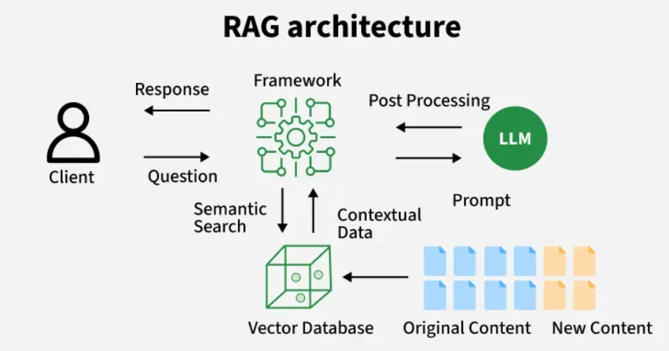

1. Data Collection
The first stage of a RAG pipeline involves gathering unstructured data from various sources, such as documents, online articles, databases, and emails. This data is typically raw and unorganized, so it needs to be collected and prepared for subsequent steps. Tools like LangChain and custom data loaders are commonly employed in this stage to handle different data formats, such as PDFs, CSV files, and web pages. This process centralizes the data, making it accessible for further processing and retrieval tasks.

2. Data Preprocessing
Once the data is collected, it often requires pre-processing to extract the relevant textual content. Raw data sources like PDFs or web pages may contain a mix of text, images, tables, and other elements, so it’s important to clean and extract just the useful information. Tools like AWS Textract or open-source libraries can assist in extracting readable text from complex documents. This stage ensures that the pipeline only works with structured, clean text, which is essential for efficient retrieval and response generation in the following stages.

3. Data Transformation
After the data is cleaned, it needs to be transformed into a format suitable for embedding and subsequent retrieval. This step often involves splitting documents into smaller chunks, known as chunking. Chunking is crucial because many models, especially embedding-based ones, have token limits that require breaking large text blocks into smaller, manageable pieces. This step is also important for maintaining semantic coherence across smaller chunks. In cases where documents are complex or lengthy, the challenge is to ensure that chunking doesn't lose context, as coherent segments are essential for quality retrieval and response generation.

4. Embedding and Representation
In this stage, the chunks are transformed into high-dimensional vectors or embeddings. These vectors represent the meaning of the text in a format that makes it easy for the system to search for similar content in a vector database. Embedding models like OpenAI’s text-embedding-ada or domain-specific models (such as Mistral AI) generate these embeddings. The vectors allow the system to perform efficient similarity searches and retrieve the most relevant pieces of data based on a user’s query. The generation of accurate embeddings is critical for the retrieval system’s performance, as it directly impacts the quality of the data returned for response generation.

5. Storage and Persistence
Once the data has been embedded, it is stored in a specialized vector database designed for high-dimensional data. Vector databases are optimized to quickly handle large volumes of embeddings and efficiently perform similarity searches. This stage ensures that the embeddings are stored in a structured and indexed format, making them easily accessible for future queries. Additionally, the persistence layer needs to store metadata (such as document IDs or source links) alongside the embeddings to keep track of the context of each retrieved chunk. Maintaining this structured storage is crucial for fast, real-time response generation.

6. Updating and Refreshing
Over time, new data becomes available, and existing documents may change. This stage of the pipeline addresses the need for regular updates to the stored embeddings. As fresh data is ingested and processed, the embeddings must be updated in the vector database to maintain the relevance of responses. Without regular refreshing, the pipeline may generate outdated responses, diminishing its accuracy and effectiveness. The refreshing process ensures that the system remains synchronized with the latest information, improving the reliability of the model's output as it continuously adapts to new content.

Building a RAG Pipeline for LLM

1. Importing the Libraries
The required libraries for loading documents, chunking text, embeddings, vector storage, and model generation are imported. This includes LangChain for workflow management, HuggingFace for embeddings and model generation, and Chroma for vector database functionality.
import os
from typing import List, Dict, Any
from getpass import getpass

from langchain.document_loaders import WebBaseLoader
from langchain.text_splitter import RecursiveCharacterTextSplitter
from langchain.embeddings import HuggingFaceInferenceAPIEmbeddings
from langchain.vectorstores import Chroma
from langchain.llms import HuggingFaceHub
from langchain.chains import RetrievalQA
from langchain.schema import Document

2. Loading the Data
The WebContentLoader class loads content from provided URLs using LangChain’s WebBaseLoader and converts it into documents. It includes error handling to ensure content is successfully loaded.
class WebContentLoader:
def __init__(self, urls: List[str]):
self.urls = urls

def load_content(self) -> List[Document]:
loader = WebBaseLoader(self.urls)
try:
documents = loader.load()
print(f"Successfully loaded content from {len(self.urls)} URLs")
return documents
except Exception as e:
print(f"Error loading content: {str(e)}")
return []

3. Chunking the Text
The DocumentChunker class splits documents into smaller chunks using LangChain’s RecursiveCharacterTextSplitter. This allows for better processing by creating manageable text pieces with overlap for context preservation.
class DocumentChunker:
def __init__(self, chunk_size: int = 256, chunk_overlap: int = 50):
self.splitter = RecursiveCharacterTextSplitter(
chunk_size=chunk_size,
chunk_overlap=chunk_overlap
)

def create_chunks(self, documents: List[Document]) -> List[Document]:
chunks = self.splitter.split_documents(documents)
print(f"Created {len(chunks)} chunks from {len(documents)} documents")
return chunks

4. Embeddings
The HuggingFaceEmbeddings class uses HuggingFace’s API to convert text into vector embeddings, capturing semantic meaning for effective similarity-based search.
class HuggingFaceEmbeddings:
def __init__(self, model_name: str = "BAAI/bge-base-en-v1.5"):
# Get HuggingFace token if not already set
if 'HUGGINGFACEHUB_API_TOKEN' not in os.environ:
hf_token = getpass("Enter your HuggingFace API token: ")
os.environ['HUGGINGFACEHUB_API_TOKEN'] = hf_token

self.embeddings = HuggingFaceInferenceAPIEmbeddings(
api_key=os.environ['HUGGINGFACEHUB_API_TOKEN'],
model_name=model_name
)

def get_embeddings(self):
return self.embeddings

5. Vector Database
The VectorStore class stores embeddings in Chroma, enabling efficient querying by creating a searchable vector store from the documents.
class VectorStore:
def __init__(self, embeddings):
self.embeddings = embeddings
self.vectorstore = None

def create_store(self, documents: List[Document]) -> Chroma:
self.vectorstore = Chroma.from_documents(
documents=documents,
embedding=self.embeddings
)
return self.vectorstore

6. Retrieval
The Retriever class uses Chroma to retrieve relevant documents based on a query, applying Maximum Marginal Relevance (MMR) to optimize for relevance and diversity.
class Retriever:
def __init__(self, vectorstore: Chroma, k: int = 3):
self.retriever = vectorstore.as_retriever(
search_type="mmr", # Maximum Marginal Relevance
search_kwargs={"k": k}
)

def get_relevant_documents(self, query: str) -> List[Document]:
return self.retriever.get_relevant_documents(query)

7. Prompt Templates
The PromptManager class creates prompts in the Zephyr format, providing context to the model and guiding it to generate accurate responses.
class PromptManager:
@staticmethod
def create_zephyr_prompt(query: str, context: str = "") -> str:
return f"""
<|system|>
You are an AI Assistant that follows instructions extremely well.
Please be truthful and give direct answers. Please tell 'I don't know' if user query is not in context
</s>
<|user|>
Context: {context}

Question: {query}
</s>
<|assistant|>
"""

8. Model Generation
The ResponseGenerator class uses HuggingFaceHub to load a language model, which processes the query and retrieved context to generate responses.
class ResponseGenerator:
def __init__(self, model_id: str = "HuggingFaceH4/zephyr-7b-alpha"):
self.model = HuggingFaceHub(
repo_id=model_id,
model_kwargs={
"temperature": 0.5,
"max_new_tokens": 512,
"max_length": 64
}
)

def create_qa_chain(self, retriever) -> RetrievalQA:
return RetrievalQA.from_chain_type(
llm=self.model,
retriever=retriever,
chain_type="stuff"
)

9. RAG Pipeline
The RAGPipeline class integrates all components - loading, chunking, embeddings, retrieval, prompt creation, and model generation - into a unified pipeline that processes queries and generates responses based on relevant documents.
class RAGPipeline:
def __init__(self, urls: List[str]):
self.loader = WebContentLoader(urls)
self.chunker = DocumentChunker()
self.embeddings = HuggingFaceEmbeddings()
self.vectorstore = None
self.retriever = None
self.generator = None

def build(self):
documents = self.loader.load_content()
chunks = self.chunker.create_chunks(documents)
vector_store = VectorStore(self.embeddings.get_embeddings())
self.vectorstore = vector_store.create_store(chunks)
retriever_component = Retriever(self.vectorstore)
self.retriever = retriever_component.retriever
self.generator = ResponseGenerator()
self.qa_chain = self.generator.create_qa_chain(self.retriever)

def query(self, question: str) -> str:
prompt = PromptManager.create_zephyr_prompt(question)

response = self.qa_chain(prompt)
return response['result']

Example Usage
The main function demonstrates using the RAGPipeline, processing the data and generating a response for the query, "What is recurrent neural network?"
def main():
# Using two of our amazing articles as examples
urls = [
"https://www.geeksforgeeks.org/nlp/stock-price-prediction-project-using-tensorflow/",
"https://www.geeksforgeeks.org/deep-learning/training-of-recurrent-neural-networks-rnn-in-tensorflow/"
]

pipeline = RAGPipeline(urls)
pipeline.build()

query = "What is recurrent neural network?"
response = pipeline.query(query)

print(f"\nQuery: {query}")
print(f"Response: {response}")

if __name__ == "__main__":
main()

Techniques for Optimisation of RAG
The efficiency of Retrieval-Augmented Generation Systems can be enhanced by using various optimisation techniques. These techniques improve performance, reduce latency and ensures the relevance of responses by the system.
- Query Expansion: It enhances retrieval accuracy by adding related terms or synonyms to the original query. Using semantic embeddings, queries can be enriched with contextually similar terms which helps in improving the chances of finding the best match in large datasets.
- Early Stopping in Generative Models: Early stopping in generative models prevents unnecessary token generation by stopping the response once it is sufficiently complete. This helps to avoid redundancy while keeping responses relevant and concise.
- Pipeline Parallelism: It optimises the RAG process by running retrieval and generation tasks simultaneously on different hardware, reducing wait times. While one part of the system retrieves documents, the other can generate the response. Parallel execution cuts down processing time and maximises hardware potentials.
- Multi-Stage Retrieval: It involves an initial broad search followed by a refined search for the most relevant documents. This step-by-step approach ensures the retrieval process is efficient and precise. This helps in reducing overhead by narrowing the focus progressively.
- Memory Usage: They require more memory for storing external knowledge but can offload retrieval tasks unlike transformer models that store everything within the model itself.

Applications of RAG
Lets see the applications of RAG architecture in various fields,
- Customer Support: By integrating RAG with chatbots, businesses can provide more accurate and context-aware answers by pulling in real-time information from company knowledge bases, FAQs and support documents.
- Healthcare: Medical professionals get benefit from RAG by retrieving the latest research, treatment guidelines and clinical data to assist in decision-making and it ensures that the information is current and evidence-based.
- Legal: Legal professionals use RAG to retrieve up-to-date case laws, regulations and legal precedents to generate responses that are grounded in the most relevant and recent legal information.
- Finance: Financial analysts use RAG systems to access the latest market data and financial reports which helps them make informed decisions quickly and accurately.

Advantages of RAG Architecture
- Up-to-Date Responses: RAG enables LLMs to generate answers based on the most current external data rather than being limited to pre-trained knowledge that may be outdated.
- Reduced Hallucinations: By grounding the LLM's response in reliable external knowledge RAG reduces the risk of hallucinations or generation of incorrect data, ensuring that model provides more factual accuracy.
- Domain-Specific Responses: RAG allows LLMs to provide answers that are more relevant to specific organizational needs or industries without retraining.
- Efficiency: RAG is cost-effective compared to traditional fine-tuning as it allows models to be updated with new data without needing retraining.

Challenges
- Data Quality: The accuracy of RAG’s output depends heavily on the quality of the retrieved documents. If the retrieval mechanism pulls in irrelevant or incorrect data, the response may be affected.
- Latency: The retrieval process can introduce delays, especially when dealing with large datasets. Optimizing retrieval efficiency is crucial to maintaining a responsive system.
- Complexity: RAG systems involve multiple moving parts which are embedding models, retrieval mechanisms and generative models. Ensuring all these components work seamlessly together can be technically complex.
- Scalability: As the volume of data grows, scaling the retrieval and generative component to handle larger datasets becomes increasingly challenging.
The world of Large Language Models (LLMs) is rapidly evolving, offering exciting possibilities for tasks like text generation, translation, and question-answering. But how do we optimize model performance and enhance the user experience of these powerful models to perform specific tasks effectively? That’s where Prompt Engineering, Retrieval-Augmented Generation (RAG), and Fine-tuning come into play.
While they all aim to enhance LLM performance, they differ significantly in their methods and applications.
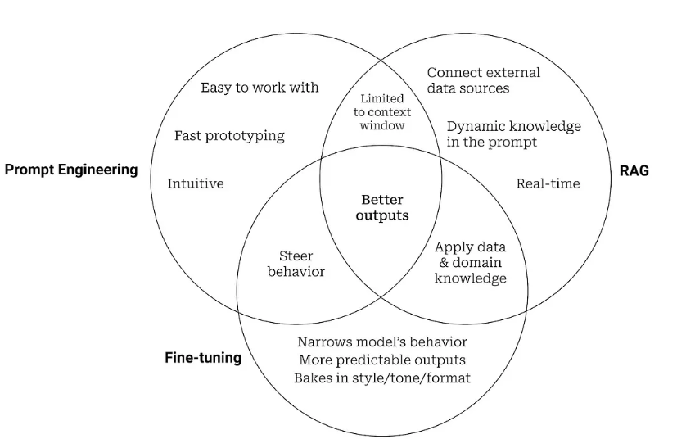
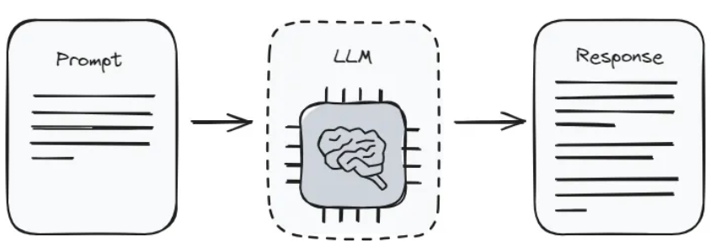

Key Benefits of Prompt Engineering
- Simplicity: Prompt engineering does not require modifying the model itself, making it a straightforward approach.
- Flexibility: It allows for quick adjustments and iterations to improve model outputs.
- Cost-Effective: Prompt Engineering is often more economical since it doesn’t involve training new models.

What is Retrieval-Augmented Generation (RAG)?
Imagine providing a chef with information beyond the recipe, like specific cooking techniques or ingredient substitutions.
RAG takes a similar approach by combining prompt engineering with an external knowledge retrieval system. It retrieves relevant information from a pre-built database based on the prompt and feeds it to the LLM, resulting in more informed and contextually rich outputs.
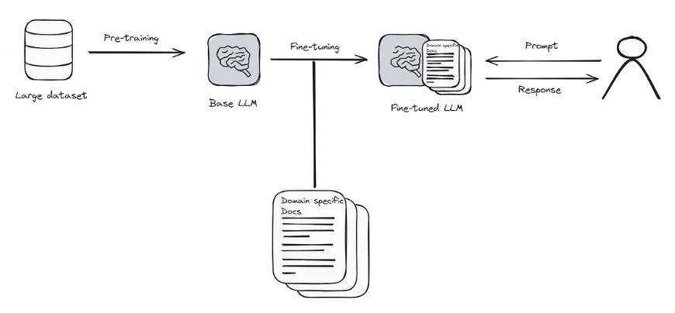

Key Benefits of RAG
- Enhanced Relevance: By leveraging external knowledge sources, RAG provides more accurate and contextually appropriate responses.
- Scalability: It can handle large datasets and provide real-time responses by quickly retrieving and generating information.
- Dynamic Knowledge Integration: RAG allows the model to incorporate the latest information, which is crucial for domains where knowledge is constantly evolving.

What is Fine-Tuning?
Imagine giving a chef extensive training in a specific cuisine. Fine-tuning is the most intensive approach, involving training the LLM on a dataset specifically tailored to the desired task. This dataset consists of input-output pairs that demonstrate the specific task and the expected outcome. Through this training, the LLM’s internal parameters are adjusted, making it more adept at handling the specific task.
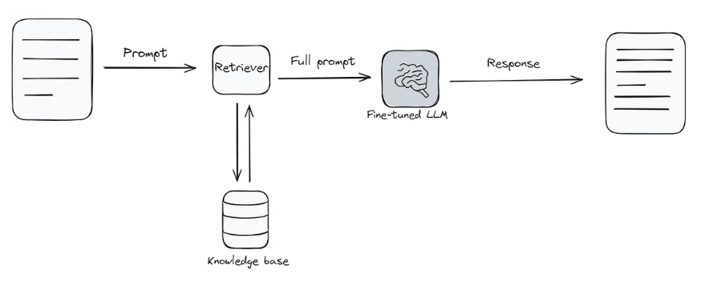

Key Benefits of Fine-Tuning
- Highest level of control: Fine-tuning provides precise control over the LLM’s output, which makes it an ideal technique for tasks requiring high accuracy and consistency.
- Versatility: Fine-tuning can be applied to various models and tasks, making it a highly adaptable approach.

Comparing Prompt Engineering, RAG, and Fine-Tuning
Use Cases
PROMPT ENGINEERING
Best suited for scenarios where quick adjustments are needed without changing the model architecture like improving user interactions in chatbots, virtual assistants, and customer service applications.
RETRIEVAL AUGMENTED GENERATION
Effective for applications requiring up-to-date and contextually rich information, such as search engines, question-answering systems, and content generation platforms.
Preferred for specialized tasks requiring high accuracy and task-specific optimization, such as medical diagnosis, legal document analysis, and sentiment analysis.
Implementation Complexity
PROMPT ENGINEERING
Low complexity, as it involves refining input prompts rather than altering the model itself.
RETRIEVAL AUGMENTED GENERATION
Moderate complexity, requiring integration of retrieval mechanisms with generative models.
FINE-TUNING
High complexity, involving re-training of models on specific datasets and adjusting model parameters.
Cost and Resource Requirements
PROMPT ENGINEERING
Low cost and resource requirements since it doesn’t involve extensive training or data processing.
RETRIEVAL AUGMENTED GENERATION
Moderate complexity, requiring integration of retrieval mechanisms with generative models.
FINE-TUNING
High complexity, involving re-training of models on specific datasets and adjusting model parameters.
Quality of the LLM
PROMPT ENGINEERING
Highly variable because it is dependent on the skill in crafting prompts.
RETRIEVAL AUGMENTED GENERATION
High quality because it enhances responses with contextually relevant external information.
FINE-TUNING
High quality because it is tailored to specific datasets, leading to more relevant and accurate responses.
Skill Level Required to use the LLM
PROMPT ENGINEERING
Low skill level needed since it requires basic understanding of how to construct prompts.
RETRIEVAL AUGMENTED GENERATION
Moderate skill level needed since it requires basic understanding of both machine learning and information retrieval systems.
FINE-TUNING
High skill level required since it required knowledge of machine learning principles and model architectures.

Conclusion
Choosing between prompt engineering, retrieval-augmented generation (RAG), and fine-tuning depends on your specific needs and constraints. Prompt engineering offers a cost-effective and flexible approach for enhancing model performance through refined prompts. RAG provides dynamic and contextually rich responses by integrating retrieval mechanisms with generative models. Fine-tuning delivers high accuracy and task-specific optimization through re-training on targeted datasets.
By understanding the strengths and limitations of each technique, you can make informed decisions to leverage AI models effectively for your applications. Whether you need quick improvements, dynamic knowledge integration, or task-specific excellence, there’s a suitable approach among prompt engineering, RAG, and fine-tuning.
Retrieval-Augmented Generation (RAG) systems represent a significant leap forward in the realm of Generative AI, seamlessly integrating the capabilities of information retrieval and text generation. Unlike traditional models like GPT, which predict the next word based solely on previous context, RAG systems enhance responses by tapping into a vast reservoir of data, ensuring that the generated text is not only contextually appropriate but also richly informative. This makes them particularly valuable in fields such as customer support and content creation.

Overview of RAG Systems
RAG systems are all about improving automated responses by combining information retrieval with language generation. The retrieval part digs up relevant info from a database, and then the generation model takes that info to craft smart, context-aware answers. This combo means RAG systems can give you responses that are not just spot-on but also packed with the right context, which is perfect for tackling more complicated questions.
Basically, a RAG system works by looking at what a user asks and picking out important words or phrases. It then digs through a huge dataset to find the most relevant documents or sections. After that, it takes the information it found and feeds it to a language model, which puts everything together to create a clear and natural-sounding response. This way, the answer is on point and easy to understand.

Importance of Evaluation Metrics in RAG Systems
Evaluation metrics are super important for figuring out how well RAG systems are doing. They give us a consistent way to check how effectively a system pulls up relevant info and gives accurate answers. With these metrics, developers and researchers can spot where things can be better, compare different models, and make sure the system is hitting the performance goals they want.

Key Metrics for RAG System Evaluation

1. Hit Rate
Hit Rate is a way to check how often a RAG system gives answers that are pretty close to what you were looking for. It's a key measure of how accurate and reliable the system is, especially when you really need precise information. A higher Hit Rate means the system is doing a good job of finding and generating responses that meet what users want.
Calculation Method
- Function Definition: We define a function named calculate_hit_rate() which accepts two parameters:
  - responses: A list containing the system-generated answers.
  - ground_truth: A list of the expected correct answers.
- Implementation Details:
  - The function iterates through pairs of responses and ground truth values.
  - It counts the number of instances where the system-generated response matches the expected answer exactly.
  - The Hit Rate is then calculated as the ratio of these correct matches to the total number of ground truth answers, providing a straightforward measure of the system’s accuracy.
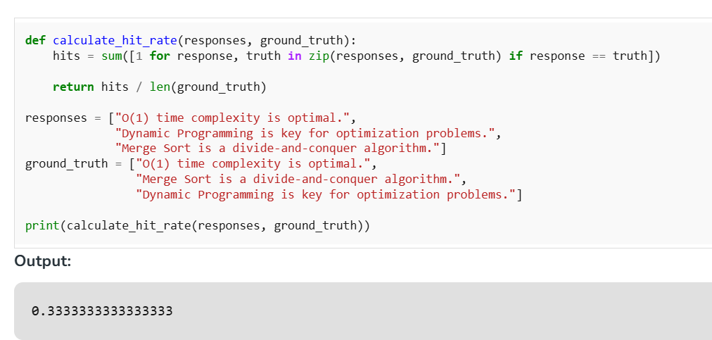
The Hit Rate of "0.3333333333333333" suggests that approximately 33.33% of the responses generated by the RAG system were exactly what was expected or matched the ground truth data perfectly.

2. Mean Reciprocal Rank (MRR)
Mean Reciprocal Rank (MRR) is another key metric for checking how well RAG systems perform. Basically, it looks at how fast the system can pull up the right answer, showing how good it is at finding useful info. MRR is especially handy when the order of answers matters. Since it tells us how close the correct answers are to the top of the list. The higher the MRR, the better the system is at putting the right answers in upfront.
Calculation Method:
- Function Definition: We define a function named calculate_mrr() which accepts two parameters:
  - responses: A list of responses generated by the RAG system.
  - ground_truth: A list containing the correct or expected answers.
- Implementation Details:
  - Initialize an Empty List: Start with an empty list to hold the reciprocal values of the ranks where the correct answers are found.
  - Iterate Through Ground Truth: For each correct answer in the ground_truth list, find its rank in the responses list.
  - Calculate Reciprocal Rank: For each correct answer found, compute the reciprocal of its rank (1 divided by the rank position).
  - Append Reciprocal Rank: Add each of these reciprocal values to the previously initialized list.
  - Compute Average MRR: Finally, calculate the average of these reciprocal values to obtain the MRR score.
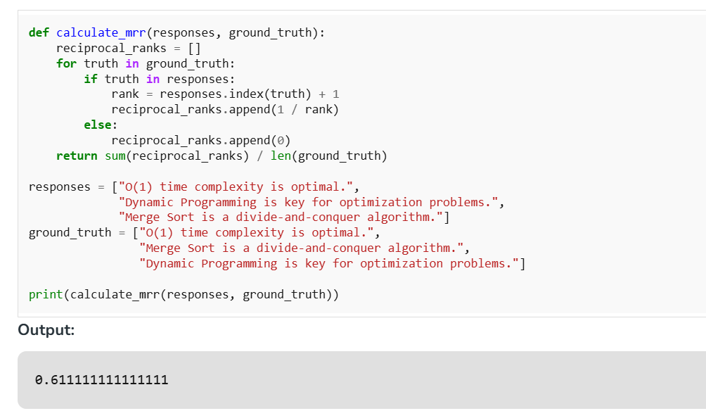
The Mean Reciprocal Rank (MRR) of "0.611111111111111" gives an insightful look into the efficacy of a Retrieval-Augmented Generation (RAG) system in ranking relevant responses.

3. Relevancy
Relevancy is super important when it comes to checking how well a RAG system’s answers line up with what the user is asking. It’s like figuring out if the system is giving back info that really matches what the user is looking for. If the relevancy score is high, that means the system is doing a great job of getting what the user needs, which is key for providing helpful and on-point info.
Calculation Method
- Function Definition: We define a function named calculate_relevancy() which accepts two parameters:
  - responses: A list of responses generated by the RAG system.
  - query: The user’s query as a string, which the responses should address.
- Implementation Details:
  - Count Relevant Responses: Iterate through the list of responses and count how many of them contain the user's query as a substring. This involves checking each response to see if the query string appears within it.
  - Calculate Relevancy Score: The relevancy score is then computed as the ratio of relevant responses to the total number of responses, providing a direct measure of how well the system’s outputs match the query’s intent.
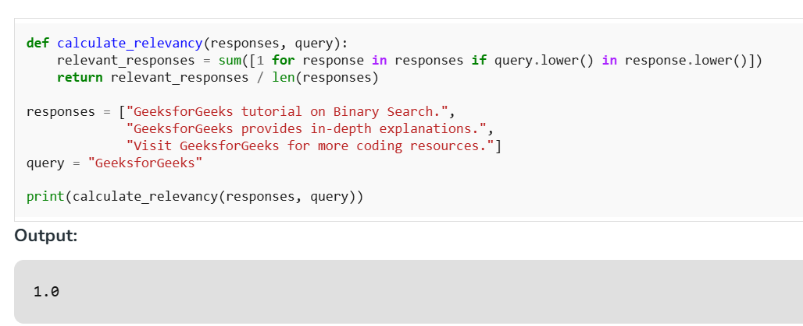
A Relevancy score of "1.0" for a Retrieval-Augmented Generation (RAG) system is highly significant, indicating optimal performance in terms of how well the generated responses align with the user's query.

Conclusion
Evaluation metrics are indispensable in the development and refinement of RAG systems. They enable developers to gauge the efficacy of their models, fine-tune configurations, and ensure the systems deliver high-quality, relevant, and accurate responses. Metrics such as Hit Rate, MRR, and Relevancy not only illustrate the performance of RAG systems but also guide improvements, ensuring these systems continue to evolve and better serve user needs. By understanding and applying these metrics, developers can significantly enhance the utility and effectiveness of RAG systems in various applications.
Retrieval-Augmented Generation (RAG) is a framework that combines the strengths of information retrieval and generative models:
- Retriever: The retriever component fetches relevant documents from a large corpus or knowledge base based on the input query.
- Generator: The generator then takes the retrieved documents and the query to generate a coherent and contextually relevant response.
It allows a model to retrieve relevant documents from a knowledge base and use those documents to augment the generation process, resulting in more accurate, context-aware and insightful responses. This approach has shown promising results in various applications such as question answering, dialogue systems and content generation. In this skill we will build a RAG Application.
Before building the model lets see how RAG Works in customer-support Help Bot:
- Query Input: A customer submits a query like "How do I return an item?"
- Document Retrieval: The retriever searches knowledge base, pulling relevant documents that can answer the query. These documents can include FAQs, return policies and product information.
- Response Generation: The generator processes the retrieved documents and the customer’s query to generate a response that integrates information from the documents, providing an accurate and helpful answer.
Lets build a Amazon Help Bot which can answer to the queries of customers.

Step 1: Install the required Libraries
Install required libraries for generating embeddings, similarity search, text generation and deep learning by running the following command.
pip install sentence-transformers faiss-cpu transformers torch

Step 2: importing Libraries
- sentence-transformers: Used for generating sentence embeddings which are vector representations of text for similarity comparison.
- faiss-cpu: A library for efficient similarity search, used to index and search document embeddings based on cosine similarity.
- transformers: A library for accessing pre-trained models such as FLAN-T5, for text generation and other NLP tasks.
- torch: A deep learning framework used to run models and perform tensor computations necessary for NLP tasks.
from sentence_transformers import SentenceTransformer
import numpy as np
import faiss
from transformers import pipeline

Step 3: Documentation Setup
A list of documents i.e knowledge base will be used to retrieve relevant context for answering customer queries. The documents might include return policies, troubleshooting guides and FAQs.
documents = [
"To track your Amazon order, log into your account, go to 'Your Orders,' and click 'Track Package' for real-time updates.",
"Amazon's return policy allows most items to be returned within 30 days of delivery for a full refund, provided they are in new condition with original packaging and accessories.",
"To return an Amazon order, initiate a return through 'Your Orders,' ship the item back, and receive a refund once processed.",
"To contact Amazon customer service, use the 'Help' section on the website or app to chat, call, or email support.",
"Amazon Prime members receive free two-day shipping, exclusive deals, and access to Prime Video and Music.",
"If your Amazon package is delayed, check the estimated delivery date in 'Your Orders' or contact customer service for assistance.",
"To cancel an Amazon order, go to 'Your Orders,' select the order, and click 'Cancel Items' if it hasn't shipped yet.",
"To purchase an Amazon gift card, visit the Amazon website, navigate to 'Gift Cards,' select a design and amount, add to cart, and complete the purchase at checkout; the gift card can be redeemed for eligible products.",
"To update your Amazon payment method, go to 'Your Account,' select 'Your Payments,' and add or edit your card details.",
"To log into your Amazon account, go to the Amazon website or app, click 'Sign In,' and enter your email or phone number and password."
]

Step 4: Embedding Generation
We will use SentenceTransformer to generate vector embeddings for the documents which represent each document numerically for similarity comparison.
embedding_model = SentenceTransformer('all-MiniLM-L6-v2')
doc_embeddings = embedding_model.encode(documents)
doc_embeddings = np.array(doc_embeddings).astype('float32')

Step 5: FAISS Index Setup
Create a FAISS index for performing efficient similarity searches using the document embeddings and normalizes the embeddings for cosine similarity.
dimension = doc_embeddings.shape[1]
index = faiss.IndexFlatIP(dimension)
faiss.normalize_L2(doc_embeddings)
index.add(doc_embeddings)

Step 6: Text Generation Pipeline
Loads the FLAN-T5 model and tokenizer from Hugging Face for generating text-based responses based on input prompts.
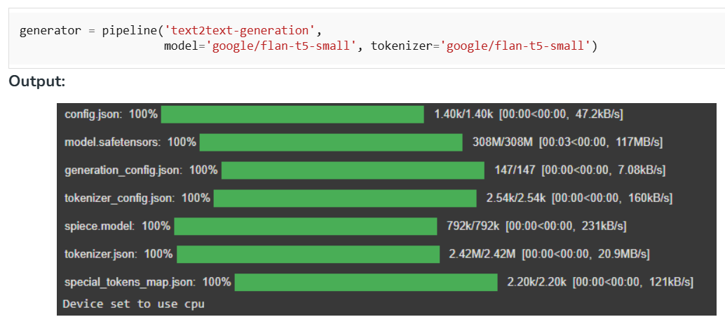

Step 7: RAG Answer Function
Retrieves the top-k most relevant documents for the query, generates a prompt and uses FLAN-T5 to generate a response based on the retrieved context.
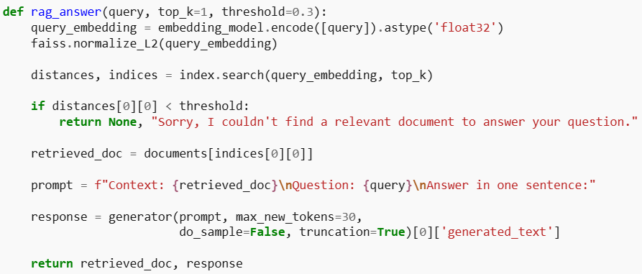

Step 8: Interactive Q&A Bot Loop
Continuously takes user input, processes the query using the rag_answer function and displays the relevant context and generated response. Ends when the user types 'exit'.
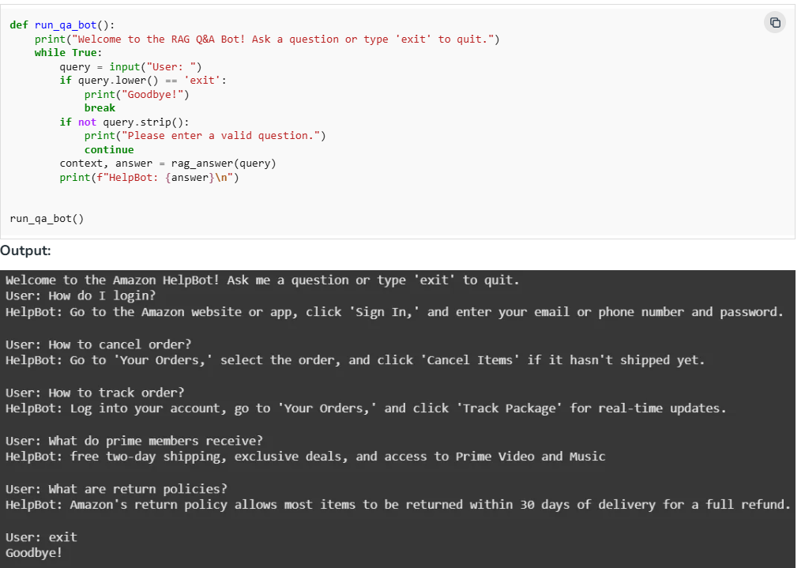

Use Cases for Help Bot:
- Customer Support: Provide real-time support for order inquiries, shipping issues and returns.
- Product Recommendations: Help customers with product suggestions based on preferences or previous purchases.
- Troubleshooting: Assist with product troubleshooting by retrieving relevant instructions or FAQ entries.
- Order Tracking: Answer queries related to order status and tracking.

Advantages
- Improved Accuracy: Access to an external knowledge base improves answer quality especially for complex topics.
- Scalability: Can easily scale by updating the knowledge base without retraining the entire model.
- Flexibility: RAG can adapt to various applications like from customer service to technical support.
- Faster Specialized Systems: Enables rapid deployment and maintenance by updating the knowledge base without retraining.

Challenges
- Computational Resources: RAG-based systems can be resource-intensive, especially for large-scale retrieval and text generation.
- Handling Ambiguity: RAG models may struggle with vague or ambiguous queries leading to irrelevant results.
- Response Length Control: Generating concise, relevant responses can be difficult leading to overly detailed answers.
- Document Retrieval Precision: Incorrect documents may be retrieved leading to inaccurate responses.

What You're Aiming For
Design and implement a Retrieval-Augmented Generation (RAG) pipeline that ingests a knowledge base (documents), builds a searchable vector index, retrieves relevant context for user queries, and generates grounded, citation-aware answers using an LLM.

Instructions

- Choose stack & tools (suggested)
  - Ingestion & orchestration: Python + LangChain
  - Embeddings: OpenAI Embeddings, Cohere, or Hugging Face embeddings
  - Vector DB: FAISS (local), Weaviate, Pinecone, or Milvus
  - LLM: OpenAI, Llama/llama-2 family, or other API/local LLM
  - (Optional) Document parsing: langchain.text_splitter, pdfminer, tika
- Data ingestion & preprocessing
  - Collect your KB (PDFs, docs, web pages, Markdown).
  - Clean text (remove boilerplate, fix encoding).
  - Split into chunks (e.g., 500–1000 tokens) with overlap for context continuity.
  - Attach useful metadata (source, title, URL, date).
- Embed & index
  - Compute embeddings for every chunk.
  - Store embeddings + metadata in your vector DB.
  - Validate by running a few similarity queries.
- Retriever design
  - Implement a retriever that returns top-k relevant chunks (k=3–8).
  - Optionally implement hybrid search (BM25 + vector) or rerank with cross-encoder.
- Prompting / Generator
  - Create a prompt template that:
    - Supplies retrieved chunks as context (with citations/IDs).
    - Asks the model to answer using only the provided context.
    - Requests explicit citations and a short confidence statement.
  - Call LLM with the prompt and context; handle token limits (truncate or prioritize).
- Evaluation
  - Create an eval set of queries + ground-truth answers (and expected sources).

Deliverables
- Working code repo with:
  - ingest.py (parsing + chunking)
  - index.py (embedding + indexing)
  - retrieve_generate.py (retriever + prompt + LLM call)
  - requirements.txt and README
- Demo: short GIF/screenshot or link showing the app answering queries with cited sources.
- Evaluation report (1–2 pages):
  - Dataset description, retrieval & generation metrics, qualitative failure cases.
  - Short analysis of hallucinations and how retrieval mitigated them.
- Reflection (5–7 sentences): what worked, main challenges, next improvement

